Memory game PRD

Product Requirements Document

1. Objective

2. Release

3. Features

4. User flow and design

# Objective

|  |  |
| --- | --- |
| Vision | *Understanding the Project making features.* |
| Goals | *The result should be the productivity of the members, for understanding the whole JS project concept* |
| Initiatives |  |
| Persona(s) | *The Project is for us* |

# Release

|  |  |
| --- | --- |
| Release | *General Release* |
| Date | *30 September 2019* |
| Initiative |  |
| Milestones | 1. *Launch the login and registration pages* 2. *Launch the main “PLAY board” page* 3. *End of Project* |
| Features | Should have:   * Registration Modal window * Log In page * Loading page * Info modal * Main Desc (where the user should play the game) * Report(generating the highest ratings)   Also should have Back END part |
| Dependencies | *The release depends on the finishing whole pages within the Team* |

# Features

|  |  |
| --- | --- |
| Feature | *All the Features are described above* |
| Description |  |
| Purpose |  |
| User problem |  |
| User value |  |
| Assumptions | *Business, user, or technical assumptions* |
| Not doing | *Anything that is out of scope for this feature* |
| Acceptance criteria | *Conditions of acceptance* |
|  |  |

# *User flow and design*

1. ***Log in page***

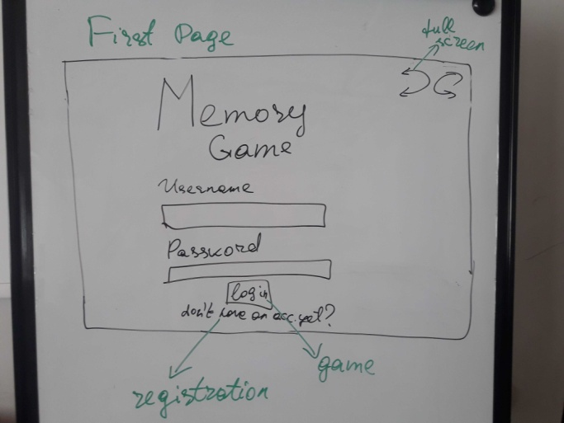

1. ***Registration Modal***

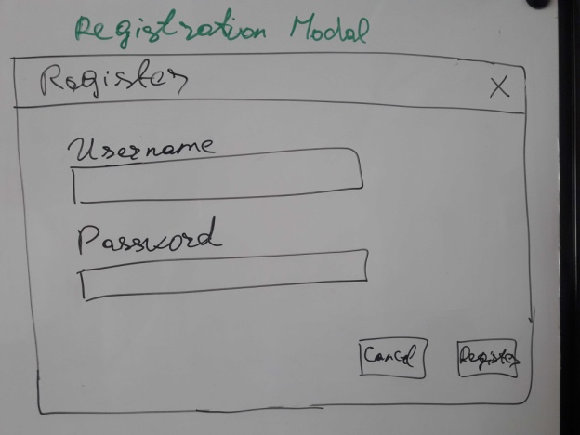

1. ***Loading page***



1. ***Rating toggle***

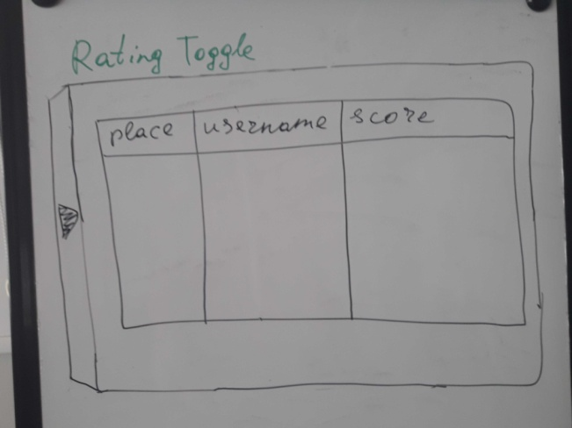

1. ***Info Modal***

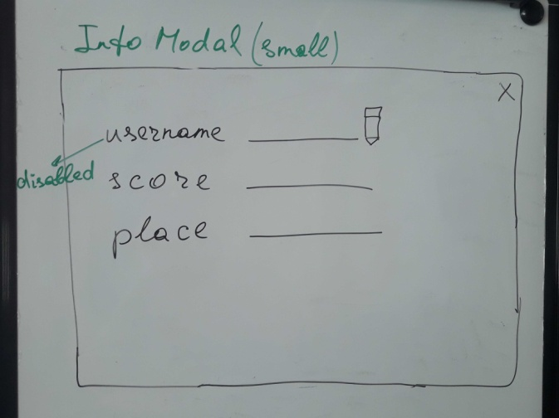

1. ***Game***

